**Experiment 9 Date: 28/03/2023**

**Aim:**

Familiarization of Linux Commands

**CO :**

Write shell scripts required for system administration

**Procedure:**

1. **Shell script to display date**

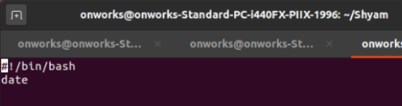

**Output**

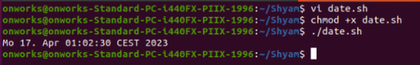

1. **Shell script to display your name:**

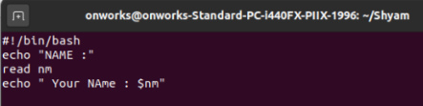

Output:

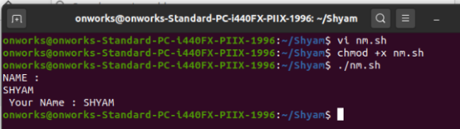

1. **Multiple Commands (ls, pwd, date, mkdir) in Shell Script**:

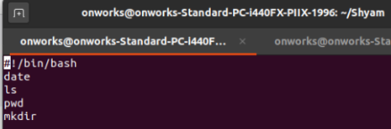

Output:

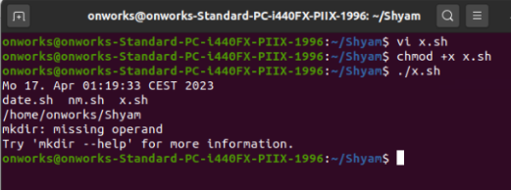

1. **Shell script to demonstrate variables**

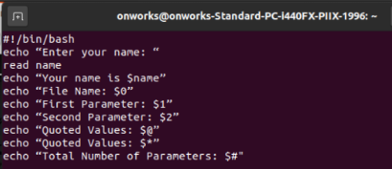

Output:

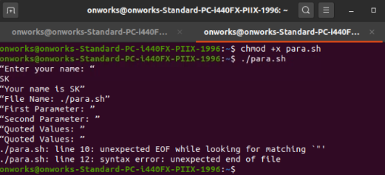

1. **Shell script to count lines and words in a file**

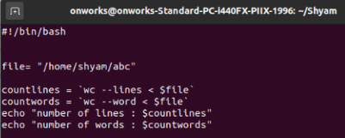

Output:

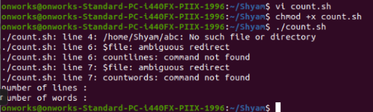

1. **Shell script to display array index**

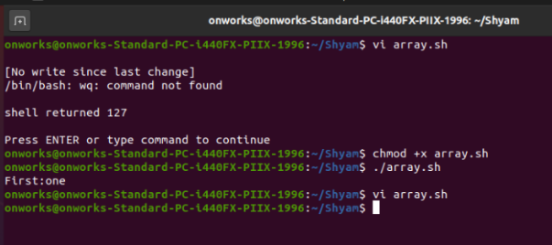

Output:

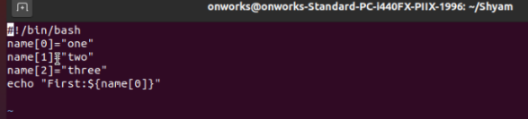

**Result**

The program was executed and the result was successfully obtained. Thus CO4 was obtained.

**Experiment 10 Date: 03/04/2023**

**Aim:**

Familiarization of Linux Commands

**CO4:**

Write shell scripts required for system administration

**Procedure:**

1. Shell script to add two number:

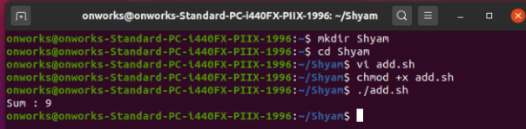

Output:

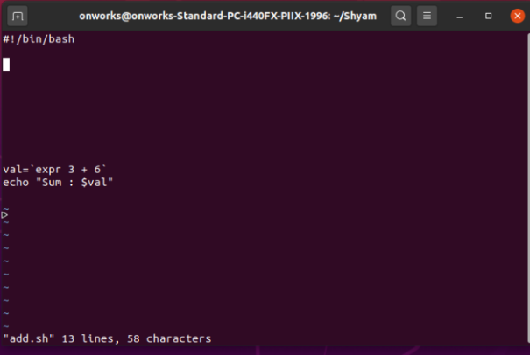

1. Write a shell script to initialize two numeric variables. Then perform addition operation on both values and store the result in the third variable.

vi filename.sh Press ‘i’ to INSERT #!/bin/bash

read -p "Enter first number " num1

read -p "Enter second number " num2

sum=$(($num1 + $num2))

echo "sum is: $sum"Press ‘Esc’ to end INSERT

:wq!

chmod +x filename.sh

./filename.sh

Output:

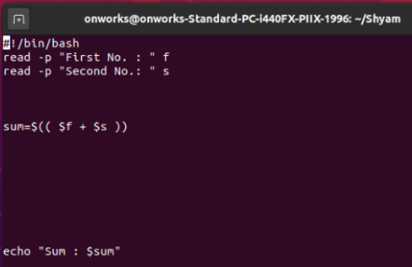

3.Shell script to read two numbers as command line parameters and perform the addition operation

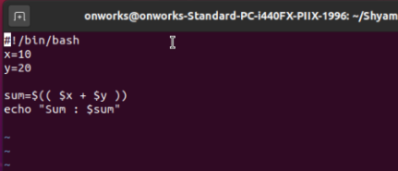

Output:

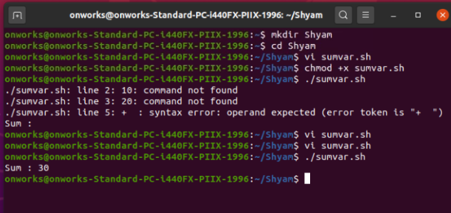

1. Shell script to demonstrate Arithmetic operators (addition, subtraction, multiplication, division, modulus, increment, decrement) by taking user input and store to another variable

vi filename.sh Press ‘i’ to INSERT

#!/bin/bash

read -p "Enter the First number: " num1

read -p "Enter the Second number: " num2

sum=$(( $num1 + $num2 ))

prd=$(( $num1 * $num2 ))

diff=$(( $num1 - $num2 ))

quo=$(( $num1 / $num2 ))

rem=$(( $num1 % $num2 ))

echo "Sum : $sum"

echo "Diff : $diff"

echo "Product : $prd"

echo "Division : $quo"

echo "Modulus : $rem"

Output:

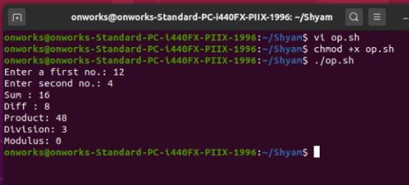

**Result**

The program was executed and the result was successfully obtained. Thus CO4 was obtained.

**Experiment 10 Date: 04/04/2023**

**Aim:**

Familiarization of Linux Commands

**CO4:**

Write shell scripts required for system administration

**Procedure:**

**1. To find the greatest among three numbers**

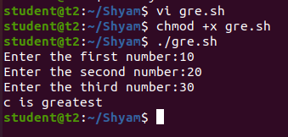

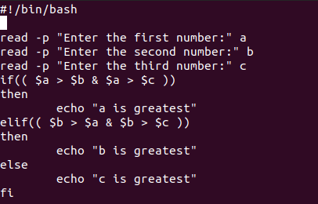

**2. To find the greatest between two numbers**

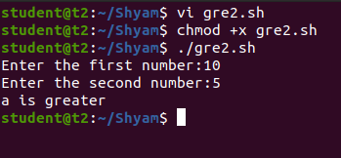

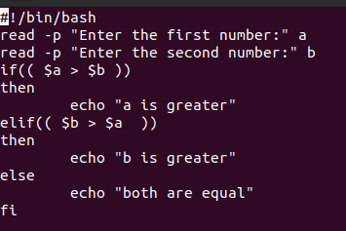

**3. To check whether a number is positive,negative or zero**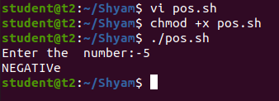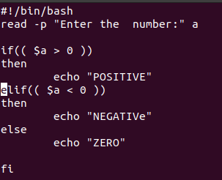

**4. To check whether a number is odd or even**

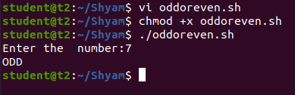

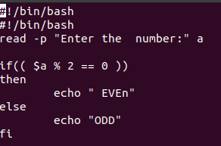

**5. To demonstrate relational operators**

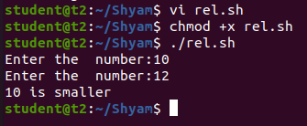

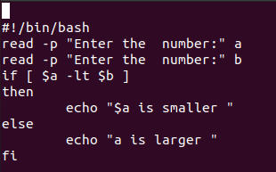

**6. To demonstrate logical operators**

**7. Shell Script to demonstrate String Operations**

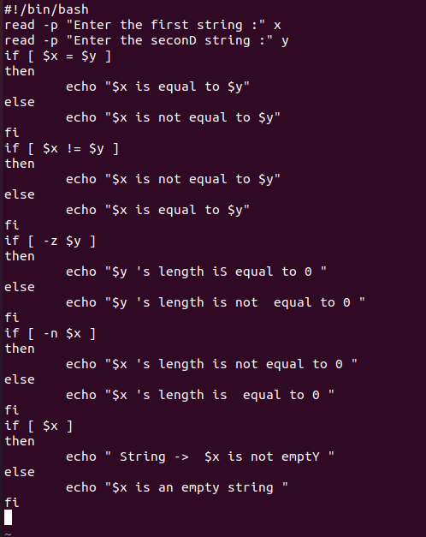

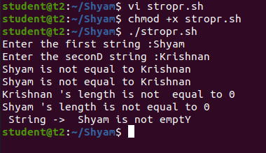

**8. Shell Script to demonstrate Bitwise operators**

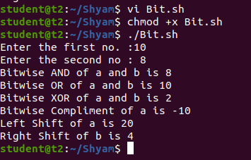

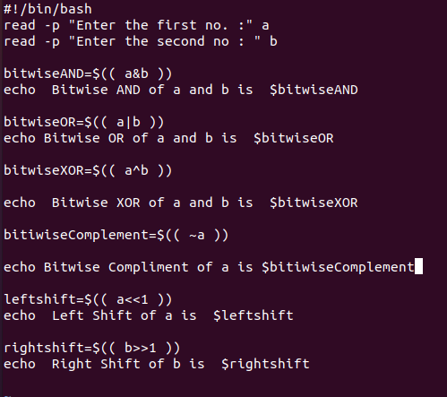

**Result**

The program was executed and the result was successfully obtained. Thus CO4 was obtained.

**Experiment 11 Date: 03/04/2023**

**Aim:**

Familiarization of Linux Commands

**CO4:**

Write shell scripts required for system administration

**Procedure:**

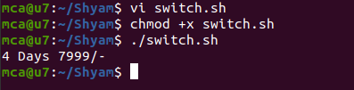

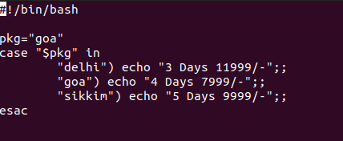

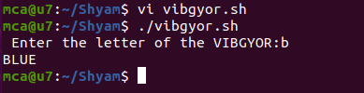

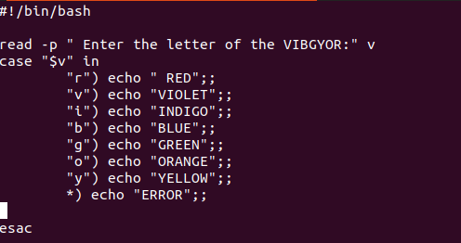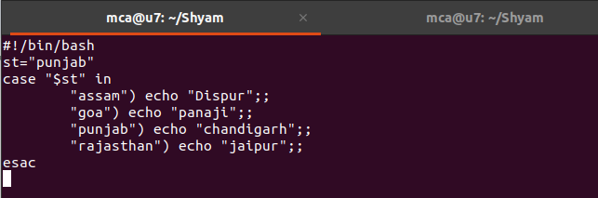

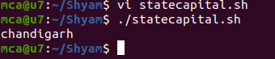

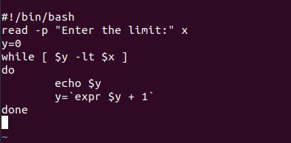

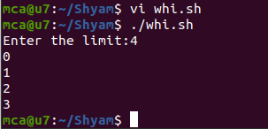

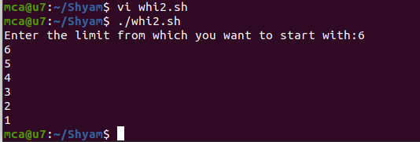

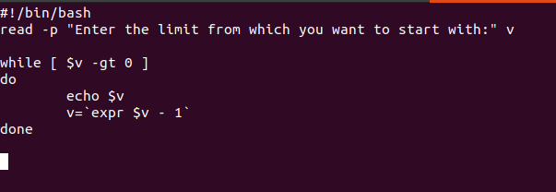

**Result**

The program was executed and the result was successfully obtained. Thus CO4 was obtained.

**Experiment 12 Date: 03/04/2023**

**Aim:**

Familiarization of Linux Commands

**CO4:**

Write shell scripts required for system administration

**Procedure:**

Implement For loop using Break statement

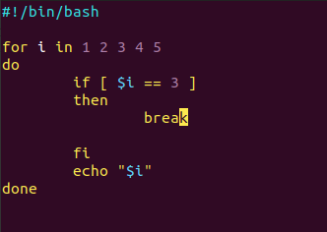

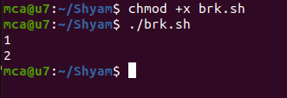

Implement For loop using Continue statement

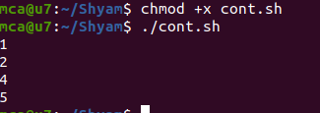

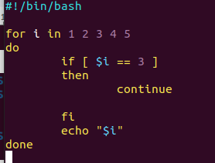

Display numbers upto 10

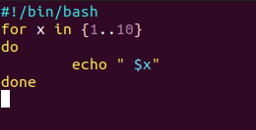

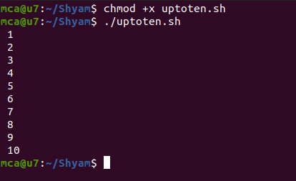

Display numbers upto 10 in reverse

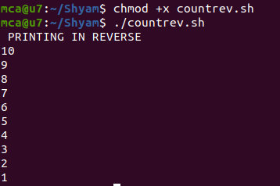

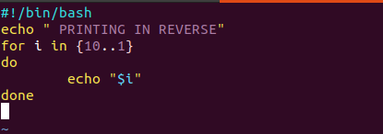

Display colours

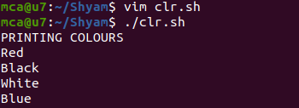

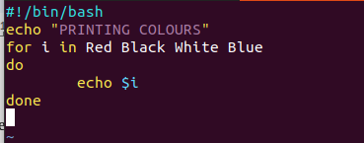

**Result**

The program was executed and the result was successfully obtained. Thus CO4 was obtained.

**Experiment 11 Date: 03/04/2023**

**Aim:**

Familiarization of Linux Commands

**CO4:**

Write shell scripts required for system administration

**Procedure:**

**Result**

The program was executed and the result was successfully obtained. Thus CO4 was obtained.

**Experiment 11 Date: 03/04/2023**

**Aim:**

Familiarization of Linux Commands

**CO4:**

Write shell scripts required for system administration

**Procedure:**

**Result**

The program was executed and the result was successfully obtained. Thus CO4 was obtained.